**Report**

**Introduction** In this report, the dataset *SleepStudy* is being used to assess the average number of hours of sleep college students get on weekdays. Specifically, it is concerned with students getting the recommended 8 hours of sleep on weeknights.

**Dataset and Methods** This report presents the findings of an analysis done on an earlier study aiming to find the relationship between college students’ personal lives, academic performance, and sleep habits. The study included 253 subjects and measured 27 distinct variables, one of which will be the focus of this report: the numerical measurement of students’ average hours of sleep on a weekday (variable *AverageSleep* within the dataset). A t-test and multiple graphical interpretations were performed to obtain the remainder of this report.

Although its report only focuses on the average hours of sleep students had on a weekday, the study collected data on students’ class, gender, depression, anxiety, stress, alcohol use, sleep habits, and all-nighters.

**Exploratory Data Analysis** This data presented in table 1 shows students have a mean, or average, of 7.866 hours of sleep per night. The middle-most, or median, data point is 7.950 hours of sleep. The interquartile range is 7.200 to 8.600 hours. The student reported a range of three hours of sleep to 10.970 hours. Looking at figure 1, it is clear that the data presents a slight left skew.

**Results** This dataset meets criteria for the central limit theorem as the sample is sufficiently large, the samples are independent of each other, and the students were randomly sampled. This report is focused on whether students are getting the recommended 8 hours of sleep, meaning the null hypothesis is that students are, on average, getting 8 hours of sleep (H0=8). The alternative hypothesis is that students are not receiving the recommended amount of sleep, meaning they are sleeping less than 8 hours (H𝛼 <8). Upon performing a t-test to determine the likelihood of this sample’s representation of the population, a p-value of 0.03459 was found. Given an alpha value of 0.05, there is not evidence to support that students are, on average, getting 8 hours of sleep. This finding has a 95% confidence interval of (-∞, 7.987216).

**Conclusion** This report has found college students, on average, are not receiving the recommended 8 hours or more of sleep per night on weekdays. This finding has a confidence interval of (-∞, 7.987216). Were the students of the college to be resampled, with 95% confidence I would assert that the average number of weekday hours of sleep would be between zero and 7.987216 hours. Given these findings, the college should take steps to ascertain why students are not sleeping enough on weekdays and how to promote healthy sleeping habits for its students.

Fig. 1

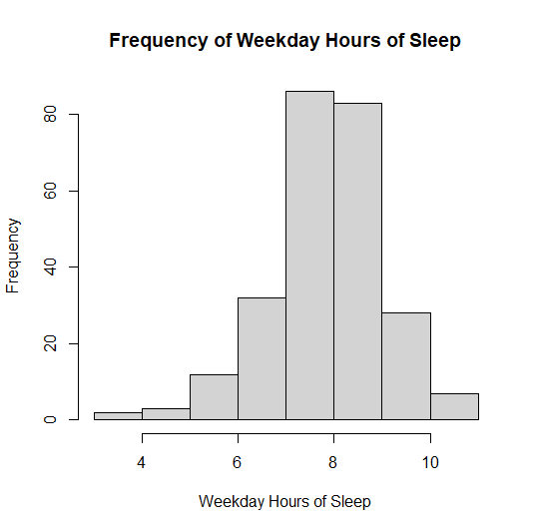

Table 1

**College Student Sleep Study Hours of Weekday Sleep**

| Minimum | 1st quantile | Median | Mean | 3rd Quantile | Maximum |
| --- | --- | --- | --- | --- | --- |
| 3.00 | 7.200 | 7.950 | 7.866 | 8.600 | 10.970 |